2021-05-18_Pre-EUA Documents Submitted to FDA CDRH as Attachments
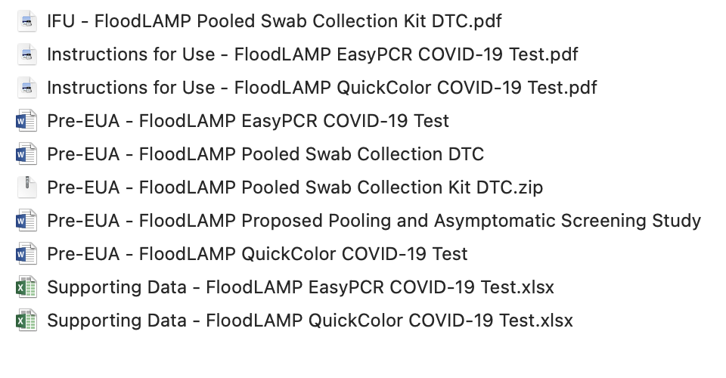
The Submission, IFU, and Supporting Data documents for the QuickColor and EasyPCR tests are the same as submitted on 3-22-21, which the FDA replied with a Deprioritization (denial to review).

2021-06-17_Email from FDA re FloodLAMP Pre-EUA
Povinelli, Benjamin <Benjamin.Povinelli@fda.hhs.gov> - postdoc at Oxford
to: "randy@floodlamp.bio" <randy@floodlamp.bio>
cc: "Caposino, Paula" <Paula.Caposino@fda.hhs.gov>, - FDA reviewer for 13 years
"St. Pierre, Don J." <don.st.pierre@fda.hhs.gov>, - Associate Director, OIVD at FDA
"Roth, Kristian" <Kristian.Roth@fda.hhs.gov>, - Supervisory Chemist - FDA/CDRH/OIR/ oir-policy <CDRH-OIR-POPS@fda.hhs.gov>,
"PEUA210313@docs.fda.gov" <PEUA210313@docs.fda.gov>
date: Jun 17, 2021, 8:06 AM subject: RE PEUA210313 signed-by: fda.hhs.gov

Good afternoon. Thank you for your pre-EUA submission, PEUA210313. As described in the U.S. Food and Drug Administration’s (FDA or Agency) guidance, “Emergency Use Authorization for Medical Products and Related Authorities,” available at https://www.fda.gov/media/97321/download, FDA prioritizes its pre-EUA activities based on a variety of factors. Given the volume of pre-EUA and EUA requests the Agency has received, we have not reviewed the validation studies nor the data provided in this pre-EUA but we provide some general recommendations below. We found 2 specific questions in your request and we provide answers below:

- Is it acceptable to utilize the FloodLAMP EasyPCRTM COVID-19 Test for determining the pass/fail of specimen adequacy? No, these studies should be designed to support the usability of the test that is subject of the EUA.
- Is it acceptable to strike this exclusion [regarding self-collection] since self-collection has become much more widespread? No. FDA recommends that participants in self-collection studies should be excluded if they have prior experience with the sample type (anterior nasal swabs). You may include participants with experience in other self-collection sample types.

In this request, you provided information on the following devices:
1. FloodLAMP QuickColorTM COVID-19 Test for the qualitative detection of RNA from SARS-CoV-2 in upper respiratory specimens including nasopharyngeal swabs, anterior nasal and mid-turbinate nasal swabs from individuals suspected of COVID-19 by their healthcare provider and from individuals without symptoms or other epidemiological reasons to suspect COVID-19 infection, when such individuals are tested as part of a testing program that includes testing at regular intervals, at least once per week.
2. The FloodLAMP Pooled Swab Collection Kit DTC is a direct to consumer (DTC) product for self-collecting pooled anterior nasal swabs in a dry tube at home (which includes a community based setting), including individuals without symptoms or other reasons to suspect COVID-19. Specimens collected using the FloodLAMP Pooled Swab Collection Kit DTC are transported at ambient temperature for testing at a laboratory.
3. FloodLAMP EasyPCRTM COVID-19 Test is a real-time reverse transcriptase polymerase chain reaction (RT-PCR) assay intended for the qualitative detection of RNA from SARS-CoV-2 in upper respiratory specimens including nasopharyngeal swabs, anterior nasal and mid-turbinate nasal swabs from individuals suspected of COVID-19 by their healthcare provider and from individuals without symptoms or other epidemiological reasons to suspect COVID-19 infection, when such individuals are tested as part of a testing program that includes testing at regular intervals, at least once per week.

We recommend you refer to the following resources. After reviewing the resources below, if you decide to submit EUAs for each of the tests, please submit your complete requests with information and data adequate to support that your device is validated for its intended use and meets the criteria for issuance of an EUA under Section 564 of the Federal Food Drug and Cosmetic Act. To help facilitate the preparation, submission, and review of your EUA request, we recommend that you use the applicable template (see links below) and that you provide all of the information recommended in the template(s) to support all claims.
- Policy for Coronavirus Disease-2019 Tests. This guidance includes reference to molecular diagnostic templates that include FDA’s recommendations for performance validation testing for SARS-CoV-2 molecular diagnostic tests.

- The templates referenced in the guidance can be found here: https://www.fda.gov/medical-devices/coronavirus-disease-2019-covid-19-emergency-use-authorizations-medical-devices/vitro-diagnostics-euas . The direct link to the molecular diagnostic template can be found here: Molecular Diagnostic Template for Commercial Manufacturers (updated July 28, 2020). This template includes all of our comprehensive recommendations on the types of information to provide to support most of your claims. For our recommendations on studies designed to support home collection (i.e., DTC testing), please see our Home Specimen Collection Molecular Diagnostic Template (May 29, 2020).

  - As discussed in our templates, we recommend using only a high sensitivity EUA RT-PCR assay which uses a chemical lysis step followed by solid phase extraction of nucleic acid (e.g., silica bead extraction) as a comparator for the clinical evaluation. We recommend selecting a comparator assay that has established high sensitivity with an internationally recognized standard or FDA SARS-CoV-2 Reference Panel. We refer you to https://www.fda.gov/medical-devices/coronavirus-covid-19-and-medical-devices/sars-cov-2-reference-panel-comparative-data and recommend that you select a comparator that is highly sensitive. You propose to use the Panther Fusion SARS-CoV-2 Assay and the Aptima SARS-CoV-2 assays as comparators. These have been shown to be highly sensitive using nasopharyngeal swabs collected and transported in media as per the Instructions for Use of each EUA. If you need to select a different comparator, we recommend that you confirm the suitability of the comparator with us through CDRH-EUA-Templates@fda.hhs.gov. In addition, you should ensure that your data set includes an adequate number of challenging/low viral load specimens (20-25% of positives) as defined as those having Ct values within 2-3 cycles of the average Ct at the limit of detection for a given target as based on comparator testing with an appropriately sensitive EUA test. Furthermore, please ensure your comparator test is run as authorized/without any modifications.

  - As stated in our template, FDA believes a minimum of 95% positive and negative agreement is acceptable clinical performance. The FloodLAMP QuickColorTM COVID-19 Test demonstrated a lower PPA than what FDA believes is acceptable for this use. Therefore, we do not recommend pursuing an EUA for this test unless you can improve its sensitivity.

- If you plan to include or recommend the use of components that are currently labeled for Research-Use-Only (RUO), we offer the following recommendations. Since RUO components are not designed for clinical testing they should not be used for patient testing without additional mitigations. Further, while some requirements for products are waived during the duration of this EUA, some are not waived and these include parts of 21 CFR 820 (e.g., acceptance activities), and parts of 21 CFR 809.10 (labeling). In your EUA requests, please provide information on how you will mitigate the risks of using or recommending the use of RUO components for example by demonstrating how you will meet these conditions of emergency use authorization for any component needed for your testing that is currently labeled RUO.

- The list of previously issued EUAs for in vitro diagnostic products, which includes previously issued EUAs for SARS-CoV-2 molecular diagnostic tests with claims similar to yours, found here: https://www.fda.gov/medical-devices/coronavirus-disease-2019-covid-19-emergency-use-authorizations-medical-devices/vitro-diagnostics-euas. The instructions for use for devices from test kit manufacturers for which an EUA has been issued are made available and can help you understand the data provided from other manufacturers to demonstrate that their SARS-CoV-2 molecular diagnostic test was adequately validated and support issuance of an EUA.

- For our recommendations on evaluating the potential impact of emerging and future viral mutations of SARS-CoV-2 on COVID-19 tests, we refer you to the following guidance document: Policy for Evaluating Impact of Viral Mutations on COVID-19 tests.

- FAQs on Testing for SARS-CoV-2, that includes frequently asked questions on test development and review, test settings and test uses.

- Virtual Town Hall Series, which takes place every Wednesday from 12:15 pm to 1:15 pm. The purpose of the Virtual Town Hall Series is to help answer technical questions about the development and validation of tests for SARS-CoV-2.

- Lastly, please be advised that FDA is prioritizing review of all EUA requests for tests, taking into account a variety of factors such as the public health need for the product and the availability of the product. See https://www.fda.gov/medical-devices/coronavirus-covid-19-and-medical-devices/covid-19-test-development-and-review-faqs-testing-sars-cov-2#priorities. Based on the information provided in the request, we cannot determine if all of your tests would meet our highest review priorities.

Upon issuance of this feedback, this pre-EUA is now closed. We look forward to working with you if you decide to submit an EUA request for this device.

2021-10-05_Email from FloodLAMP to FDA re Pre-EUA
from: Randy True <randy@floodlamp.bio>
to: "Povinelli, Benjamin" <Benjamin.Povinelli@fda.hhs.gov>
cc: "St. Pierre, Don J." <don.st.pierre@fda.hhs.gov>,
oir-policy <CDRH-OIR-POPS@fda.hhs.gov>,
"PEUA210313@docs.fda.gov" <PEUA210313@docs.fda.gov>
date: Oct 5, 2021, 11:28 AM
subject: Re: RE PEUA210313

Dear Ben, Don,

Thank you for your team's reply to our Pre-EUA in June. I'm following up and would like to request an interactive review in order to obtain guidance on a number of issues, including:
- sensitivity requirement for serial screening indication, in light of our analytical and clinical sensitivity performance data;
- usability study requirements for HCP observed, at-home collection, and DTC;
- post authorization asymptomatic and pooling studies;
- current prioritization in light of our test characteristics, manufacturing capability, and potential for widespread adoption of our QuickColorTM LAMP and EasyPCRTM open protocol EUAs.

Our tests, especially the QuickColorTM LAMP test, have the potential for high impact if authorized. Being open protocol EUA submissions, we are leveraging existing very high volume manufacturing capacity of leading supply partners in the space such as New England Biolabs and LGC Biosearch. The combination of ultra low price point and quick turnaround times enable our tests to materially impact the adoption and effectiveness of testing programs in the U.S. For example, the Test-to-Stay model to avoid school closures and quarantines is being deployed in many states, but is much more testing resource intensive than standard programs. Authorization of our tests would increase access to the Test-to-Stay model and stretch funding for testing much further. Along with our mobile app and at-home/on-site pcollection kits, FloodLAMP screening programs have distinct advantages over both rapid antigen and central lab PCR programs, with respect to sensitivity and turnaround time.

For a Pre-EUA (PEUA201985) we filed last November, we had a lead reviewer assigned (Dun Liang) and had a helpful phone call with him. In January we received a detailed review of that Pre-EUA. This process was very helpful in proceeding on the validation work and preparation of our full EUA submissions. We're hoping for a similar process here. With the added complexity of the asymptomatic indication, pooling, pooled collection and app integration, it would be helpful to obtain guidance on the studies before proceeding. We recently resubmitted EUAs for our EasyPCRTM and QuickColorTM LAMP tests (EUA210581 and EUA210582), for the persons suspected of COVID and serial screening indications, and are seeking priority review. We would like to be engaged with the interactive Pre-EUA process in parallel to the full EUA review. We would include on the call our regulatory consultant and also our scientific advisor, Dr. Anne Wyllie (developer of SalivaDirectTM).

In support of some elements of our pre-EUA, we'd like to share the real world success of non-diagnostic surveillance deployments of our QuickColorTM LAMP test. This includes to date:
- 5 sites in 3 states;
- testing at an EMS leadership conference, youth summer camp, and municipal fire departments;
- 11 staff trained to run the test, 5 non-technical staff;
- approximately 800 pools run (reactions);
- approximately 2,300 people screened;
- use of our FloodLAMP Mobile App by 84 users to register on-site and at-home pooled collections;
- 3 unknown positives detected and confirmed by reflex diagnostic test;
- 26 known positives confirmed;
- no known or suspected false negatives.

We currently have 2 commercial sites operating, performing routine testing of EMS and municipal staff. Both are in the process of scaling up to screen 1,000+ people at least weekly and expand to support broader community testing including schools and workplaces.

Please let me know if you have any questions and if there's anything we can do to facilitate this process.

Best Regards,
Randy

